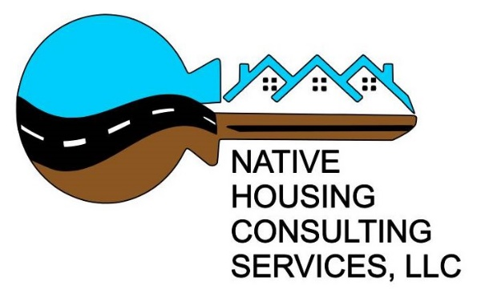

The Tohono O’Odham Ki:Ki Association has created a partnership with NHCS to provide home loans to the Members of the Tohono O’Odham Nation.

What does NHCS do?

* Assist with collection of loan documentation
* Loan Underwriting
* Review credit with borrower
* Create Action Plan for borrower to become mortgage ready
* Provide budgeting and financial education to borrower
* Assist borrower with budgeting
* Produce loan disclosures for borrower
* Produce final loan documents for borrower

Who is Native Housing Consulting Services (NHCS)?

*Strengthening families through Homeownership*

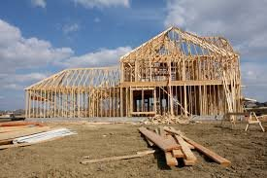

**Lisa Garcia, Director**

[lgarcia@nhcs.services](mailto:lgarcia@nhcs.services)

**Maria Cohen, Principal**

[maria@azmaria.com](mailto:maria@azmaria.com)

[www.nativehousingconsultingservices.com](http://www.nativehousingconsultingservices.com)

Phone: 480-610-1677